**Extra Info on Development of Complex Quizzes**

The information already provided is quite thorough, but here are a few other pointers that I found quite helpful:

1. First of all familiarise yourself with writing ‘cloze’ type questions in Moodle. These can then be exported into a ‘Moodle XML’ document, where you can familiarise yourself with the syntax.
2. The following link is very useful for constructing cloze questions in Moodle: <https://docs.moodle.org/29/en/Embedded_Answers_(Cloze)_question_type>
3. For example:
   1. Writing {1:NUMERICAL:=15.6:0.05#Good job!~*#Sorry. Try again.} in the question text box, and then clicking ‘Decode and Verify the Question Text’ will produce the following: 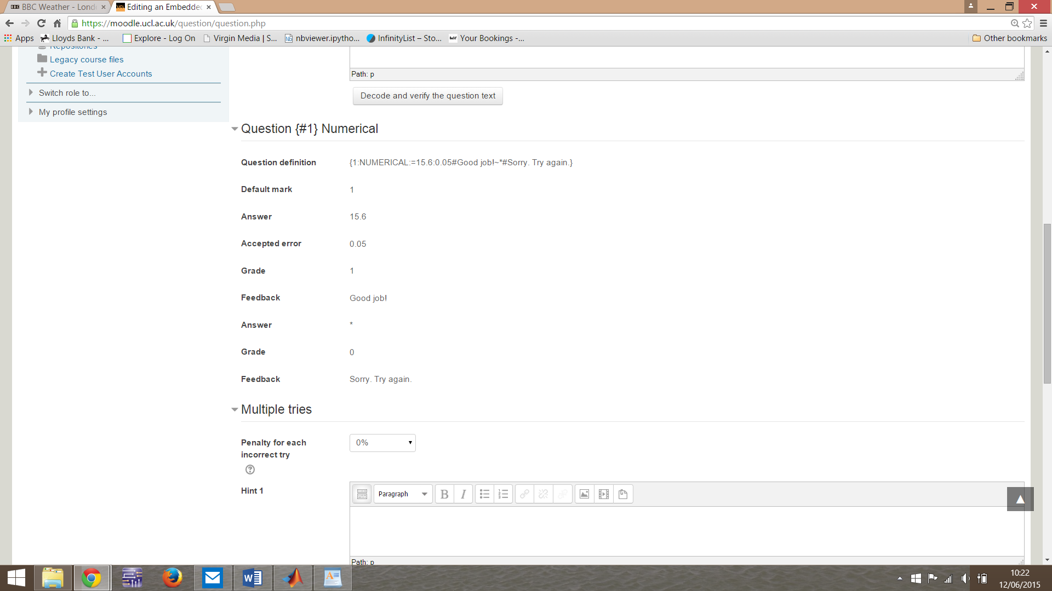
   2. You will also need to fill out the fields for question name, general feedback (which appears at the end of the question), and fill out as many hint boxes as you like (which determines both the number of hints, and the information received in each hint when an incorrect answer is inputted).
4. I found both of the following books very useful when learning the basics of Moodle and XML (both available in the library):
   1. ‘Using Moodle’ – 2nd Edition – Jason Cole and Helen Foster
   2. ‘XML – Visual Quickstart Guide’ – 2nd Edition – Kevin Howard Goldberg
5. You can then write a question in Moodle XML, and import it into Moodle, and then use it as part of a quiz.
6. You can then use Matlab code to produce N number of similar questions (usually around 100), with the same question, but with randomly generated numbers each time, and then load these questions into Moodle as a question bank, so that a question is drawn at random from the bank each time a student attempts the quiz.
7. The Matlab code can also generate a (dynamic) image particular to each generated question, or a static image. These are uploaded to a UCL web location, and can then be downloaded when the question is accessed by a student.
8. All of the code used to produce the questions for MPHY102P is available in dropbox. The most straightfoward code to look at to get an understanding of the whole process is the code used to generate the first question in the second moment of area quiz, which is found at:
   1. “training_and_examples_pack”
   2. “MPHY102_quizzes”
   3. “[I-beams_Stecia](https://www.dropbox.com/home/Complex_quizzes/training_and_examples_pack/MPHY102_quizzes/I-beams_Stecia) https://www.dropbox.com/static/images/icons/icon_spacer-vflN3BYt2.gif Level 0”
   4. “ibeam4xml.m”
9. Having been a student of this course last year, I’ve been through the quizzes and come up with some ideas of how to improve the quizzes from a student’s perspective and documented this in ‘Quiz Review’ (which I’ve uploaded to our Moodle course ‘Pilar’ Student projects testing module’, under my tab ‘Ed James’).
10. I’ve also put under this tab a folder called ‘Additional Questions’ which contains ideas for further questions for the MPHY102P module. (Which I’m yet to work on).
11. I’ve used the ideas as outlined above to produce a ‘Dynamics – Mock Exam Question’ quiz, which has 5 questions, each of which has a bank of 100 questions to draw from. I’ve included the MATLAB code on Moodle, and by simply running this code you can generate the XML documents to upload the question to Moodle.
12. I’ve also been through the pre-existing code for the MPHY102P questions and made the adjustments as per the points outlined in ‘Quiz Review’ and uploaded this updated code to Moodle also. I’ve started running the code to generate the new ‘test’ question banks (which are visible on my Moodle tab). These are still very rough and need some more work done to them when I come back on 13th July.
13. I had some problems running the arrow function in MATLAB on my own laptop, but it seemed to run ok in the laptops available in the Wolfson House Lab (however, these can be quite slow).
14. It seems that some minor adjustments need to be made to the arrow code to make it compatible with MATLAB R2014b; these are available at <http://cn.mathworks.com/matlabcentral/fileexchange/278-arrow-m>

And I have also uploaded the updated arrow function to the Moodle page